Clinic Hours  Fridays  7-9 pm  Saturdays  11-1 pm  sundays  12-2 pm*  *First Sunday of the month only  PEDIATRICS: Saturdays, 11-1pm  (Appointments recommended)  MIDWIFERY/WOMEN’S HEALTH: Thursdays 10am- 2:30pm and Saturdays 11-1pm, by appointment  PSYCHIATRY: Third Friday of the month  NUTRITION: Saturdays, by appointment  we are closed on holiday weekends | www.mcgpfreeclinic.org 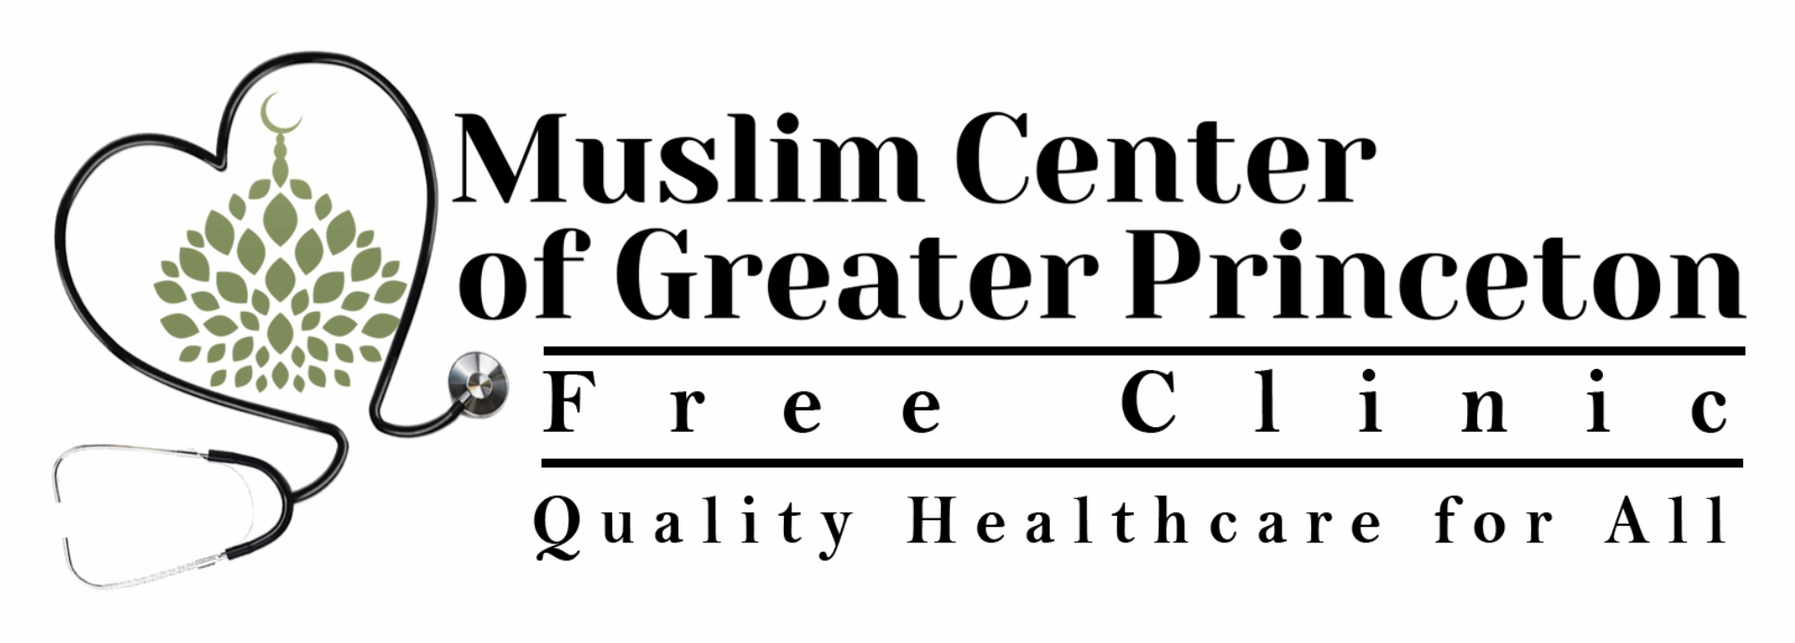  2030 OLD TRENTON ROAD, NJ 08550  WE ARE HERE FOR YOU  The MCGP free clinic is a service provided to all; the clinic does not discriminate on the basis of race, ethnicity, national origin, religion, gender, age, disability, marital status, sexual orientation, or military status. We provide services to insured and uninsured patients.  schedule an appointment today!  Tel:609-336-7602  Email: clinic@themuslimcenter.org | 609-336-7602  2030 OLD TRENTON ROAD, NJ 08550  The MCGP Free Clinic is run by volunteer healthcare providers from the community.  We are located at the Muslim Center of Greater Princeton.  2030 Old Trenton Road, West Windsor, NJ 08550  Tel: 609-336-7602  learn more on our website:  www.mcgpfreeclinic.org
609-336-7602  Our Services include  primary care  Pediatric care  women’s health  limited scpeciality care includes  initial evaluation by a cardiologist;  treatment of arthritis;  psychiatric care;  nutrition consultations;  initial pregnancy care  REFERRALS TO OTHER SPECIALISTS MADE  via Medina Community Clinic  We Provide basic onsite medical assistance to MCGP Saturday School students  Basic medicines are provided free of charge to needy patients via Rahbar Trust/Medical Home Pharmacy  Periodic Health Fairs provide Free Flu Shots, CPR Training, Routine Health Screening | www.mcgpfreeclinic.org  our providers  ALLERGY/IMMUNOLOGY AND INFECTIOUS DISEASE:  Dr. Shameen Khan  CARDIOLOGY:  Dr. Muhammad Usman Mustafa (Chairman)  EMERGENCY MEDICINE:  Dr. Hina Ghory (Credentialing Officer)  GERIATRICS:  Dr. Sajida Mokhashi  INTERNAL MEDICINE:  Dr. Arif Hussain  Dr. Farhan Malik  Dr. Shoaib Malik  Dr. Mariam Maniya  Dr. Sadia Qazi (Medical Director) | 609-336-7602  our providers  NUTRITION:  Maimoona Manzar, RDN (Registered Dietician/Nutritionist)  PEDIATRICS:  Dr. Farhat Nageen  PSYCHIATRY:  Dr. Haseeb Kazi  RHEUMATOLOGY:  Dr. Qaisar Usmani  WOMEN’S HEALTH:  Krystina Friedlander, CPM (Midwife)  all services are provided free of charge

